**Week2:**

**Exercise 1: Setting Up Junit**

**JUnit Basic Testing Exercises**

Added JUnit dependency:

<dependency>

<groupId>junit</groupId>

<artifactId>junit</artifactId>

<version>4.13.2</version>

<scope>test</scope>

</dependency>

App.test.java

Code:

package com.example;

import static org.junit.Assert.assertEquals;

import org.junit.Test;

public class AppTest

{

    /**

     * Rigorous Test :-)

     */

    @Test

    public void testAddition() {

        assertEquals(4, 2 + 2);

    }

}

**Output :**

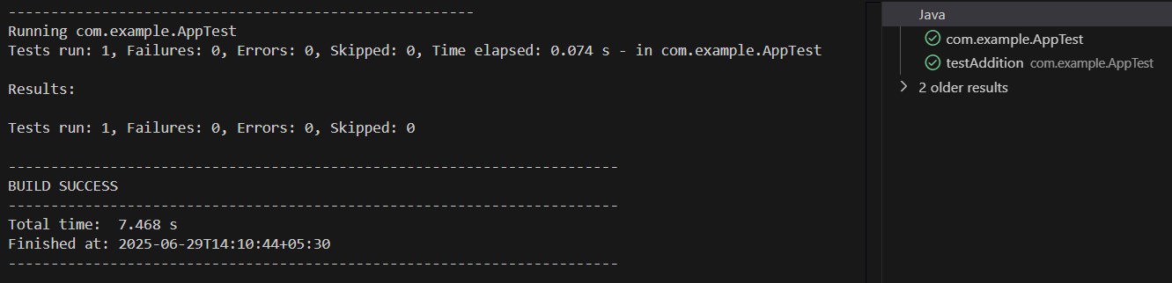

**Exercise 3:** Assertions in JUnit

AssertionsTest.java

Code:

package com.example;

import static org.junit.Assert.assertEquals;

import static org.junit.Assert.assertFalse;

import static org.junit.Assert.assertNotNull;

import static org.junit.Assert.assertNull;

import static org.junit.Assert.assertTrue;

import org.junit.Test;

public class AssertionsTest {

    @Test

    public void testAssertions() {

        assertEquals(9, 5+ 4);

        assertTrue(9 > 3);

        assertFalse(9 < 3);

        assertNull(null);

        assertNotNull(new Object());}

    }

**Output :**

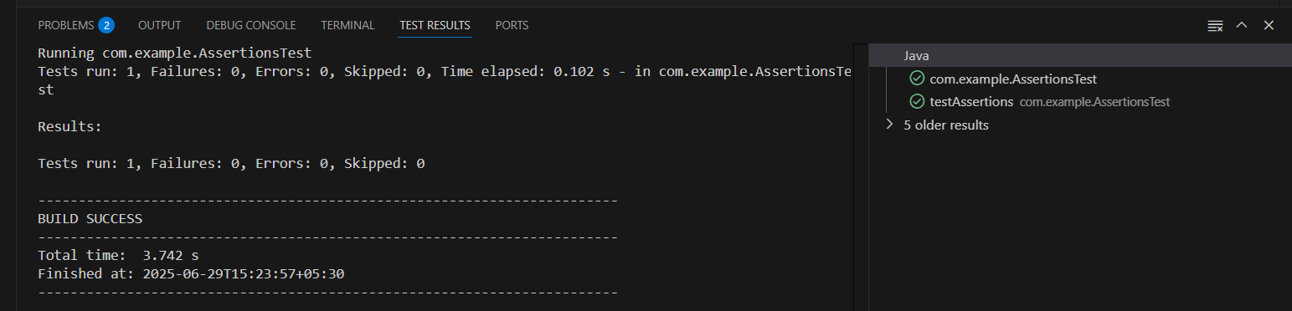

**Exercise 4:**

**Arrange-Act-Assert (AAA) Pattern, Test Fixtures, Setup and Teardown Method in JUnit.**

CalculatorTest.java

Code:

package com.example;

import org.junit.Before;

import org.junit.After;

import org.junit.Test;

import static org.junit.Assert.*;

public class CalculatorTest {

private Calculator calculator;

// Setup method: runs before each test

@Before

public void setUp() {

calculator = new Calculator(); // Arrange

System.out.println("Setup complete");

}

// Teardown method: runs after each test

@After

public void tearDown() {

calculator = null;

System.out.println("Teardown complete");

}

@Test

public void testAddition() {

// Act

int result = calculator.add(2, 3);

// Assert

assertEquals(5, result);

}

@Test

public void testSubtraction() {

int result = calculator.subtract(10, 4);

assertEquals(6, result);

}

}

Calculator.java:

package com.example;

public class Calculator {

    public int add(int a, int b) {

        return a + b;

    }

    public int subtract(int a, int b) {

        return a - b;

    }

}

Output:

